**1) Why we need to format?**

When need to replace new DUW (if there’s no Basic Package available in DUW)

When we need to use back the Integration Unlock as temporary license instead of Emergency License.

When failed to remove the license key file(LKF) manually, therefore you need to format

**1) What we are going to format?**

DUW has a hard disk that has been partitioned to c and d drive

So we need to format both drive

**2) Simple step for formatting**

Connection Cable that to be use -----------------------------🡪 For this case, 2G OMT cable can be used (for DUW30)

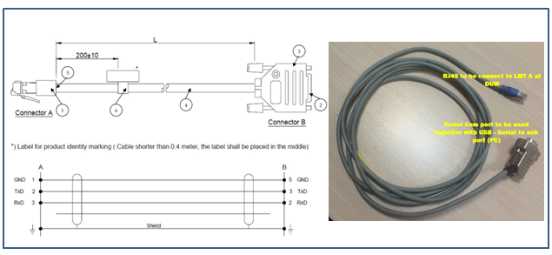

Setup Tera Term (SW that going to use)

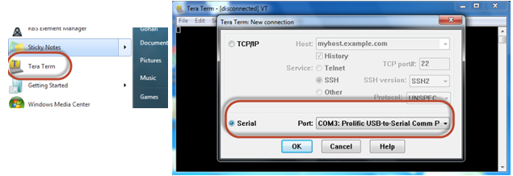

In the communication window of the terminal emulation software, click OK or press Enter.

The $ prompt is indicating that a serial connection to the DUW is established **User name =rbs Password=rbs**

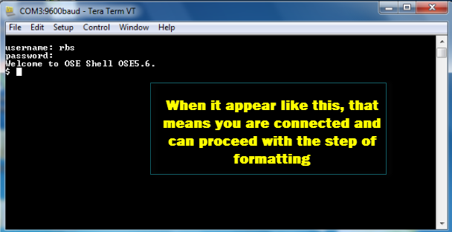

Check the volume hard drive, **vols**

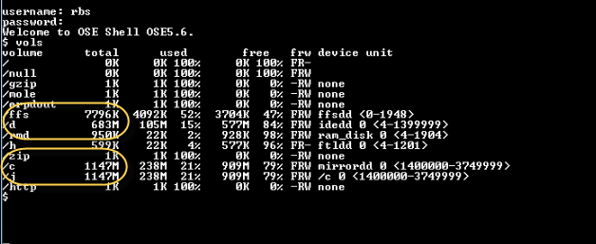

Currently we are in **Basic Mode** that we are not able to format both drive.

We only can format when it is **Backup Mode**.

So c2 and D drive will be formatted

So we need to restart the DUW to be in backup mode, using the following command:

**reload --**

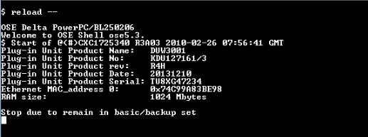

Now check the hard disk drive volume by execute following command:

**vols**

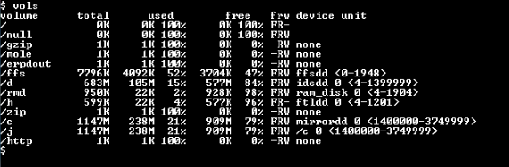

If the c2 volume is not found, use command below:

**mount_c2**

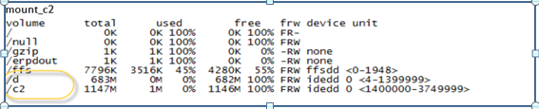

Format the hard drive partition c2 and d, using the following command

**formathd /c2**

**formathd /d**

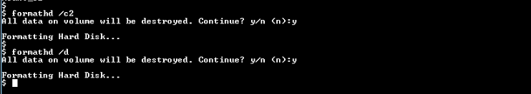

Check the volume after format and make sure is deleted

**vols**

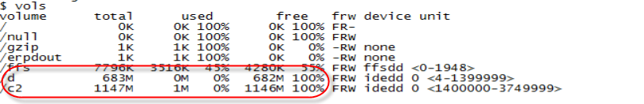

Restart the RBS in backup mode, using the following command: ---------------------🡪 (either “reload” or “ reload --“)

**reload --**

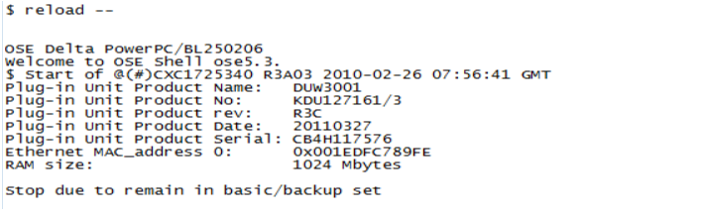

Now we are going define an IP Configuration as below: -----------------------------🡪 it can be any IP as long it is a valid IP with netmask

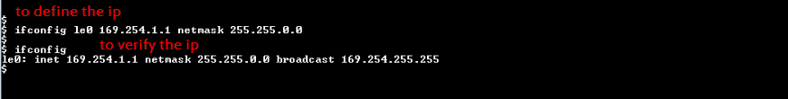

Next, we are going to connect LAN cable to the Ethernet port LMT B of the DUW.

(Ethernet crossover /Straight RJ45 to RJ45 cable for RBS)

And setting the IP as below:

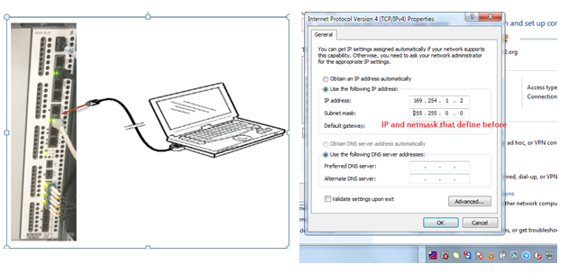

For the setting, IP address for the laptop should be 169.254.1.2 ( plus 1 from the IP of RBS)

Next we are going to load Basic Package to the DUW via File Transfer Protocol(FTP):

Preparation needed (SW for Transfer)

**BasicCV_CXP9021722_R1G01**

**BasicCV_CXP9021722_R3F01**

**FTP Application ( WS FTP95, Filezilla, Total Comander)**

**For the time being please do not close the window for Tera Term.**

**Using FileZilla Client to upload c2 drive for Basic Package**

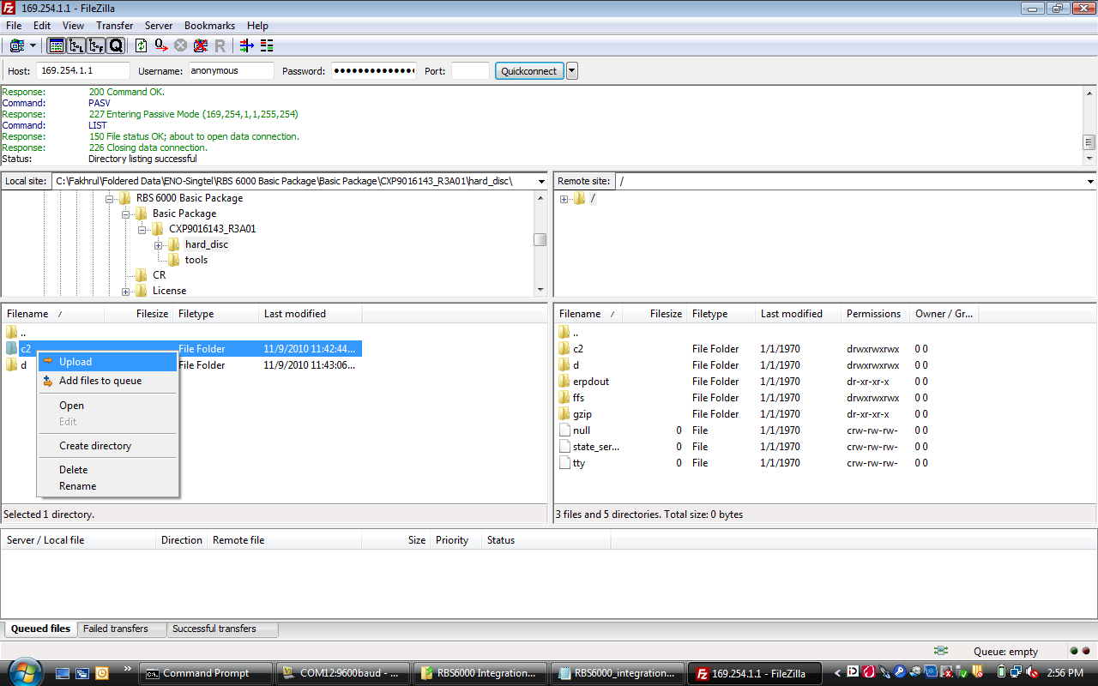

**Check volume for c2 drive**

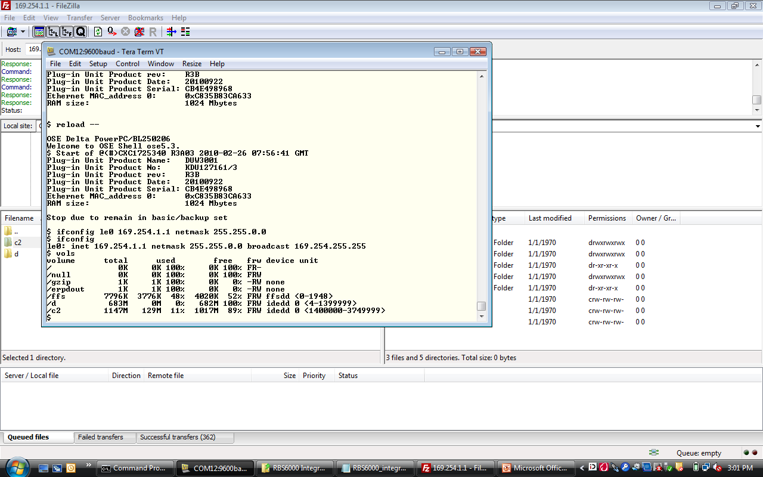

**Using FileZilla Client to upload d drive for Basic Package**

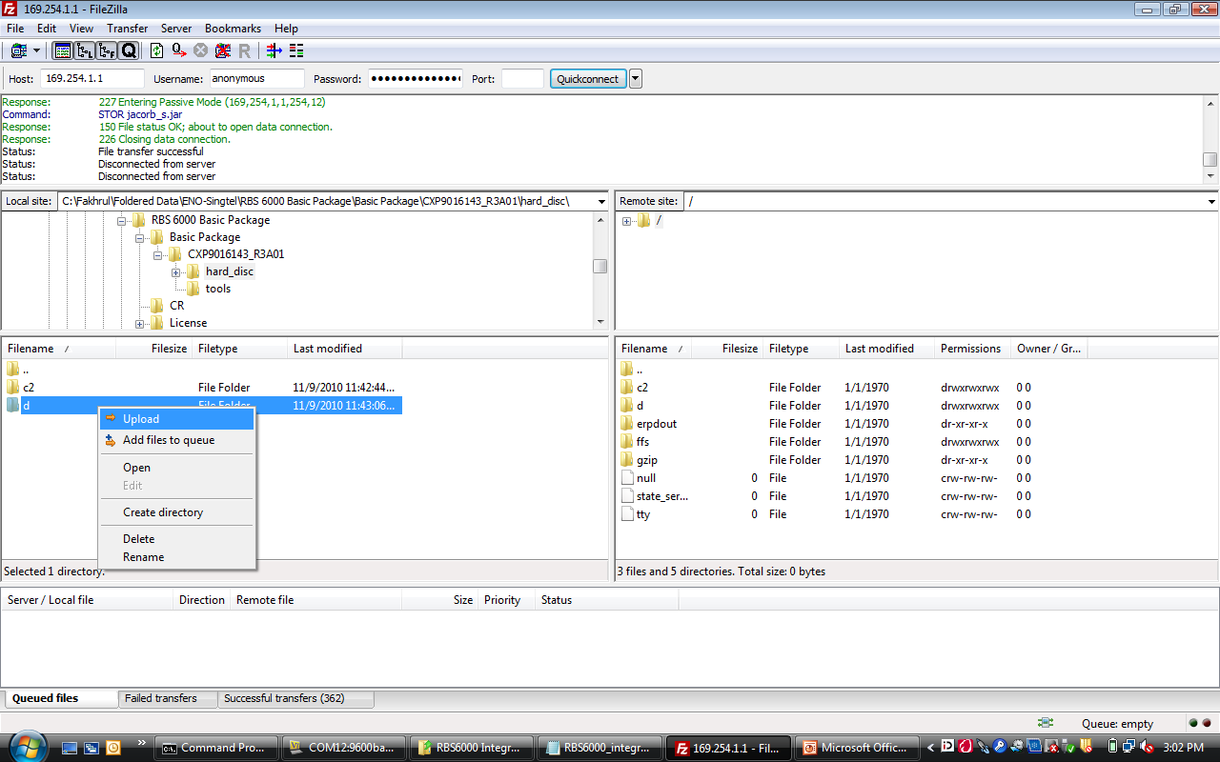

**Check volume for d drive**

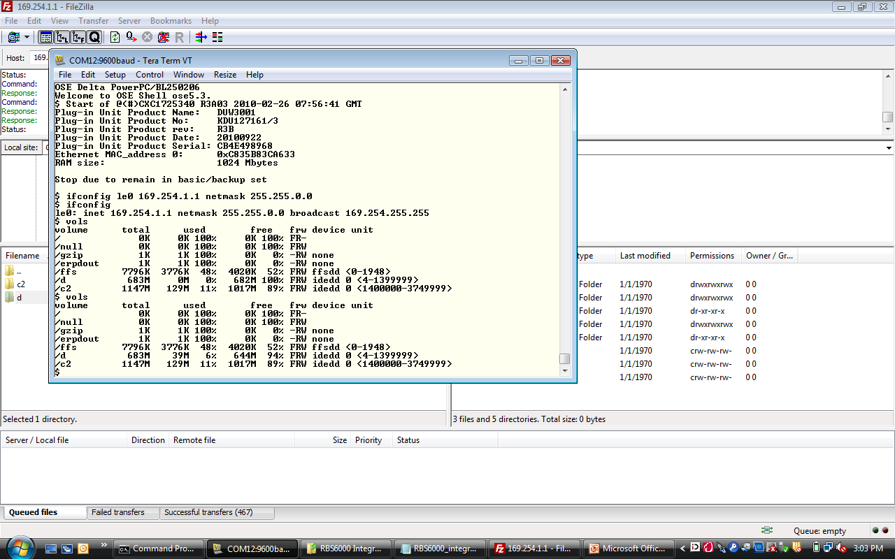

Then restart DUW to basic mode by following command in Tera Term

**reload**

The RBS restarts with the basic CV. The process can take a few minutes.

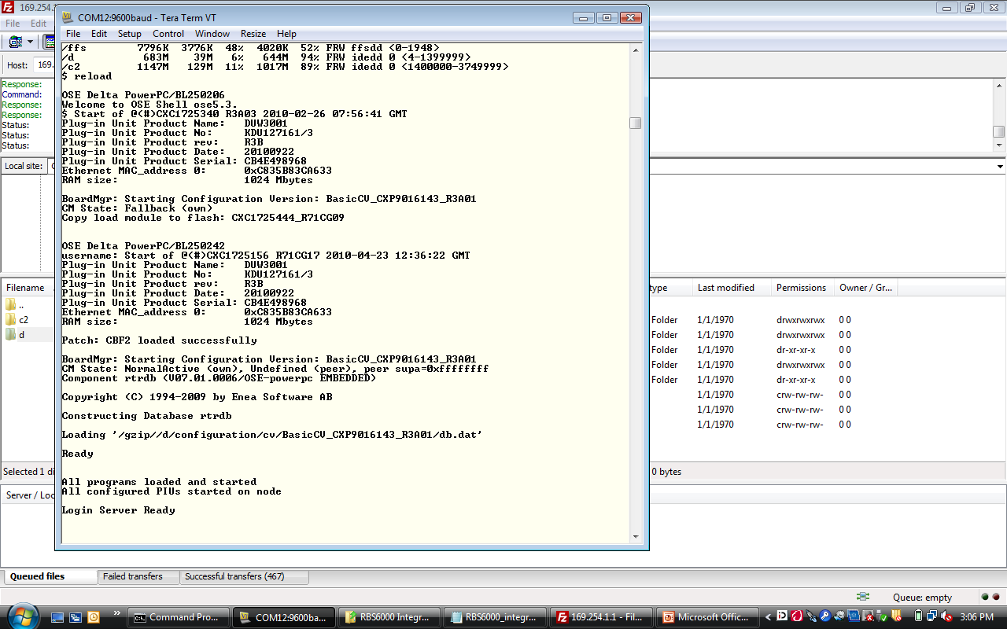

Next, Open Element Manager for Configuring the RBS with loaded script.

**Cabinet Equipment, OAM, Site Equipment, Iub and others.**

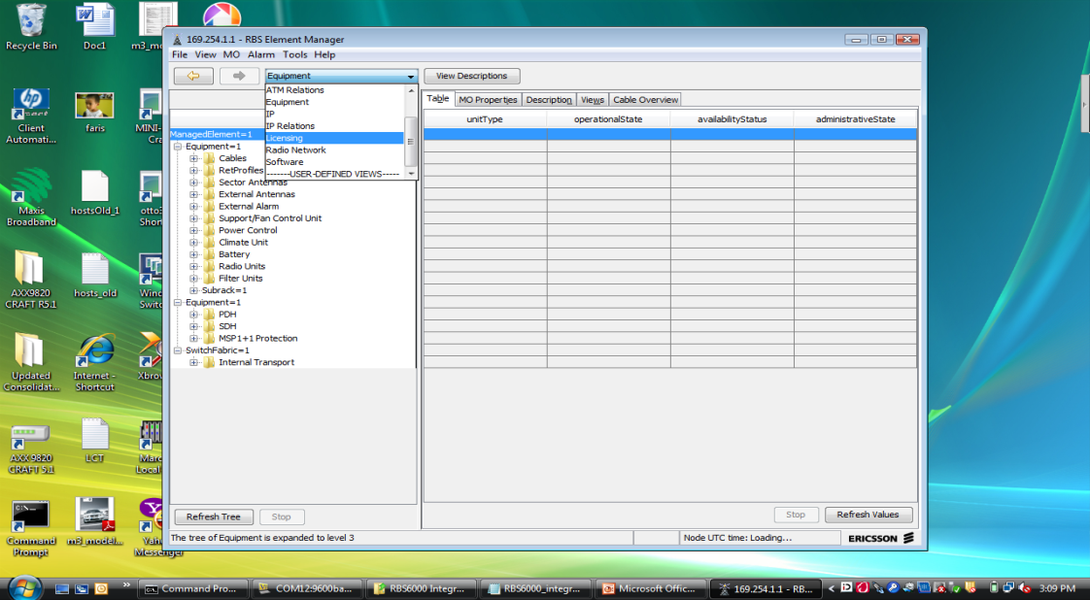

It’s done and good luck.