Firewall setting must be OFF.

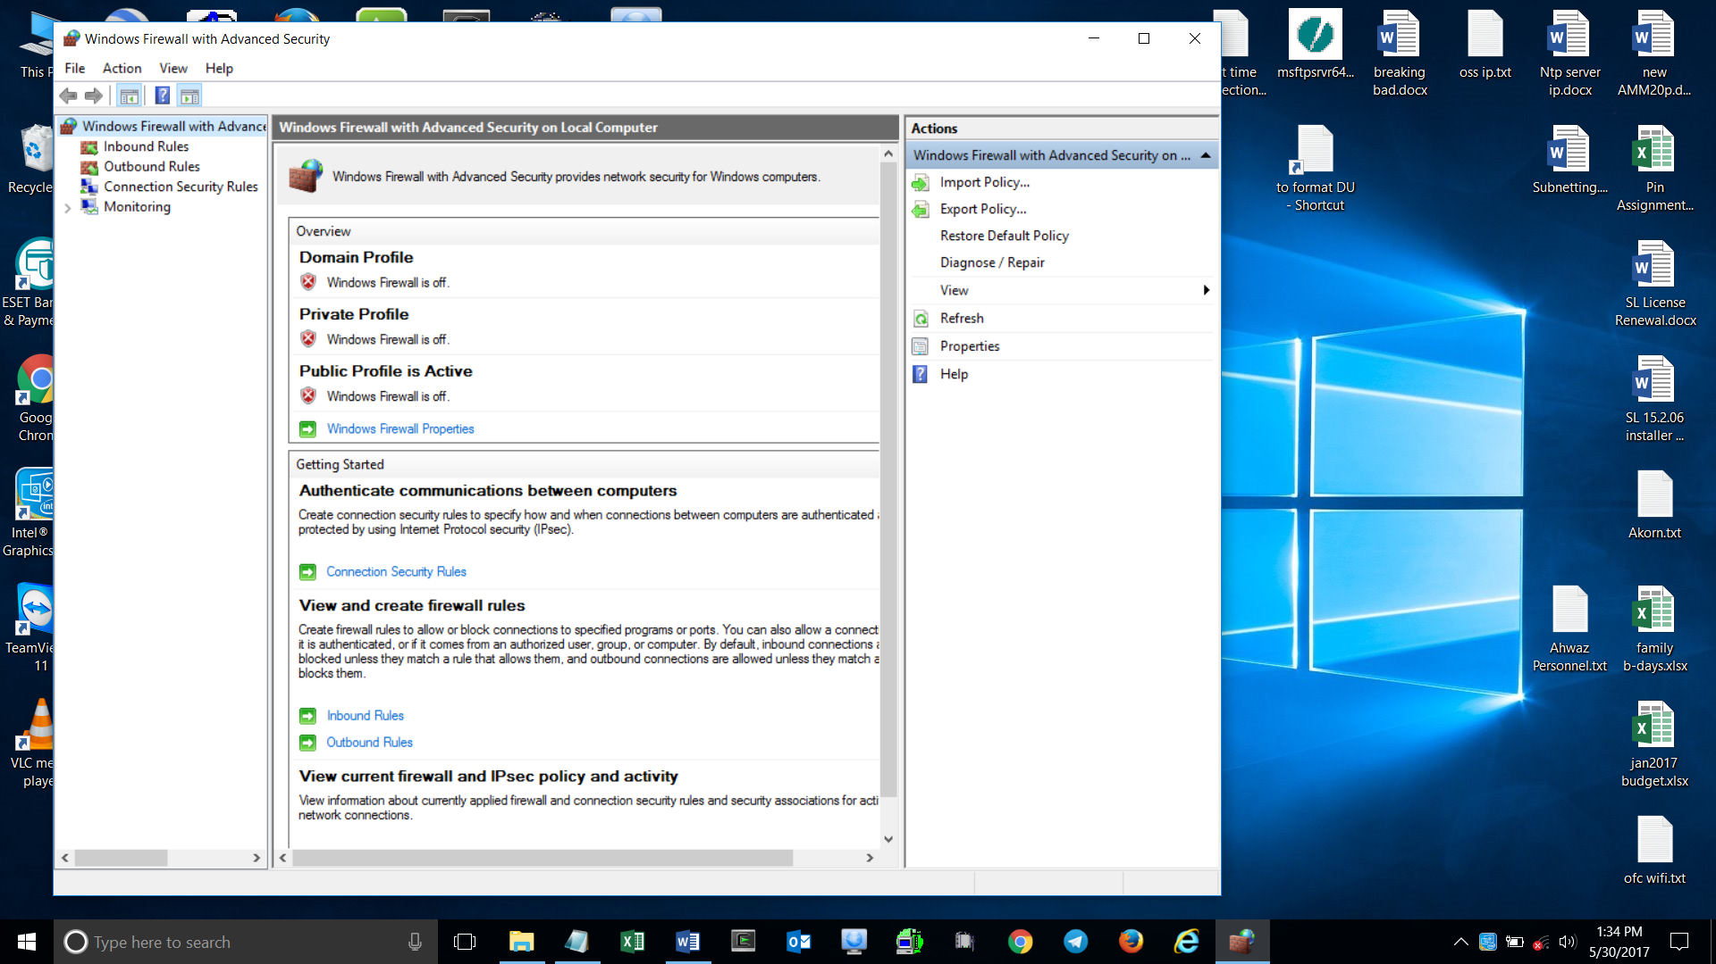

If you’re using Windows 10, locate Windows Defender & disable it.

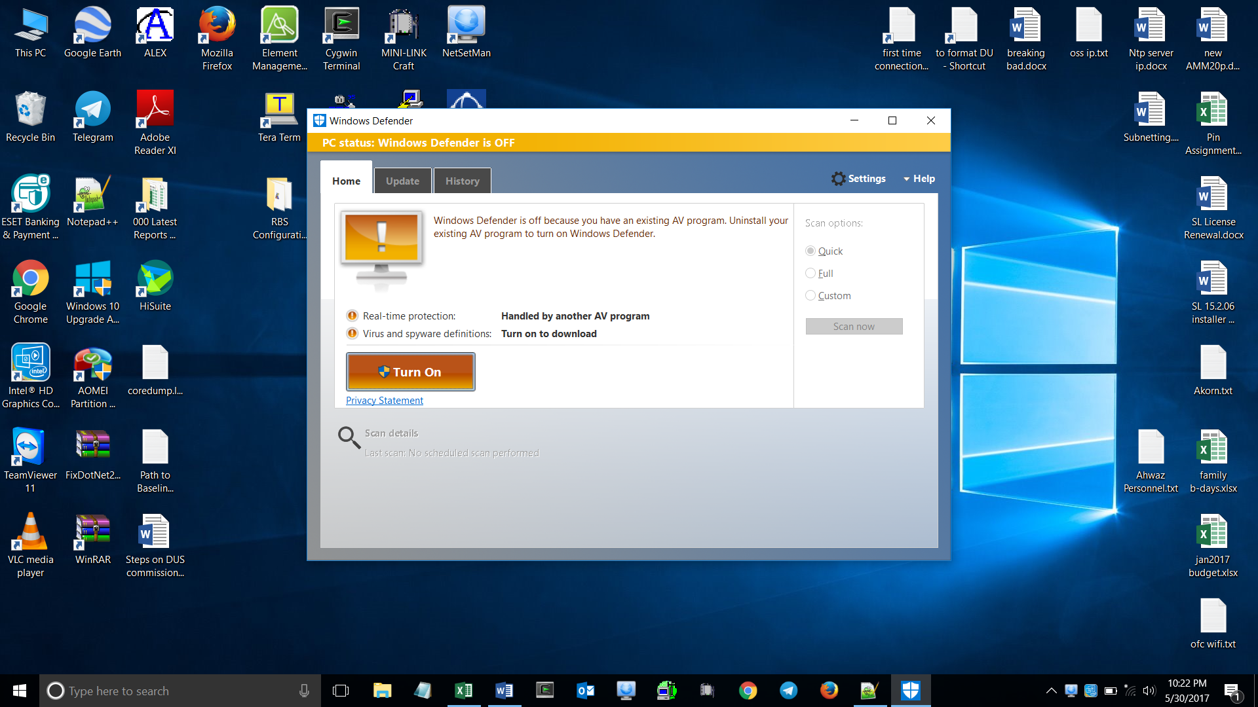

Close Wi-fi

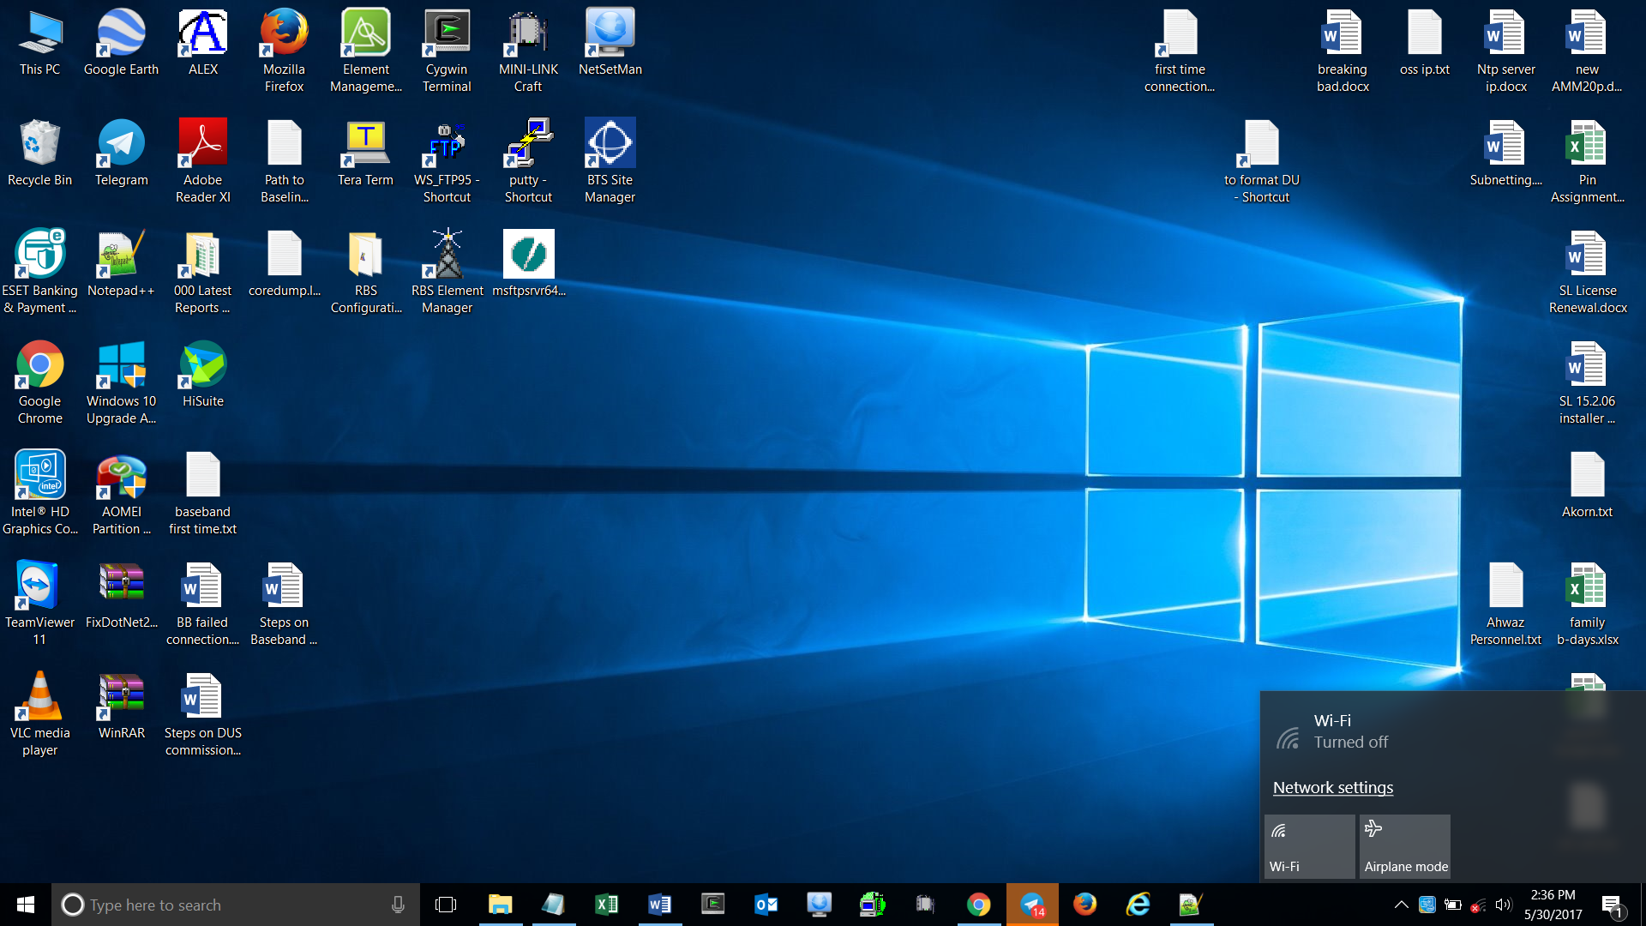

IP Setting

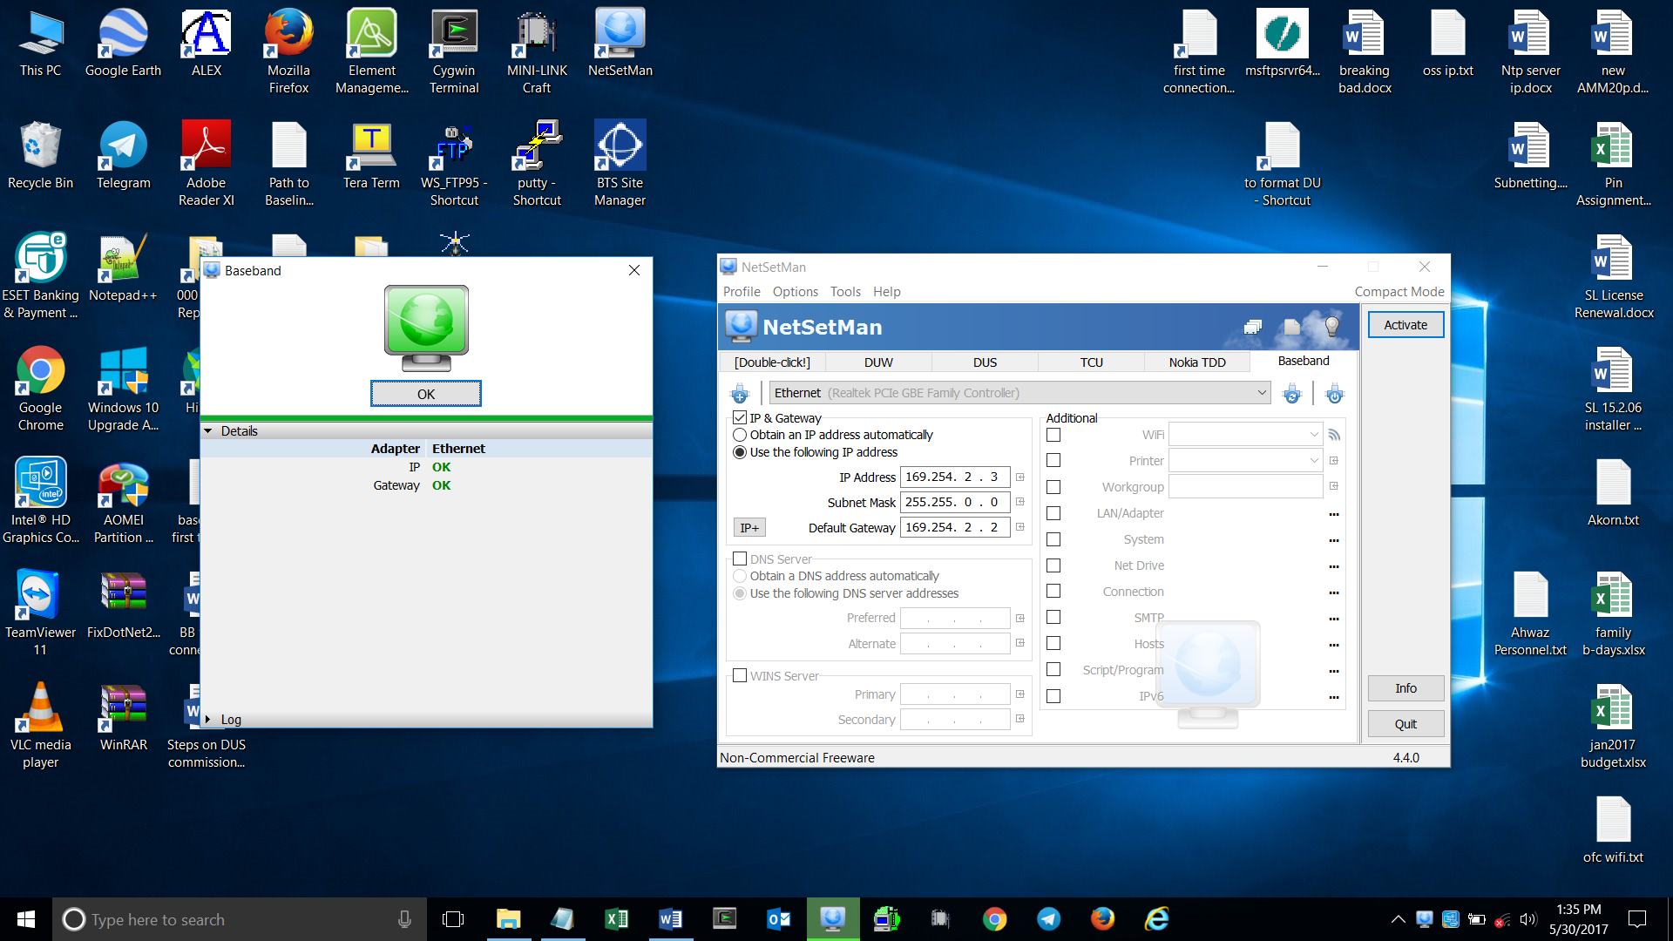

Open SFTP

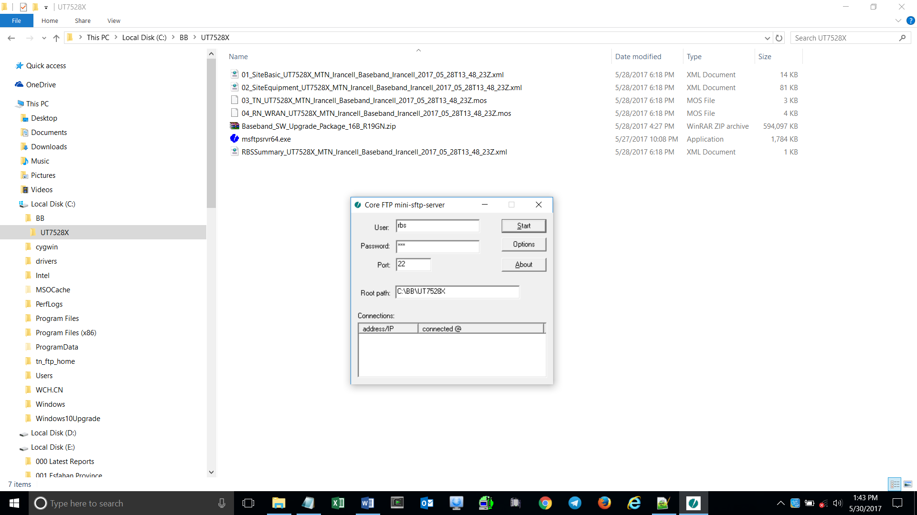

User: random (anything you like)

Password: random (anything you like)

Port: 22

Root path: use directory where your intended scripts & SW Package are located

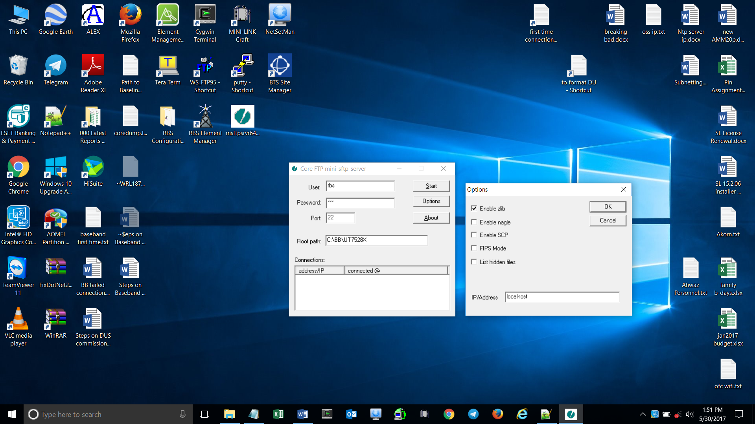

Open web browser (e.g. Firefox)

Type in https://169.254.2.2/ea.html

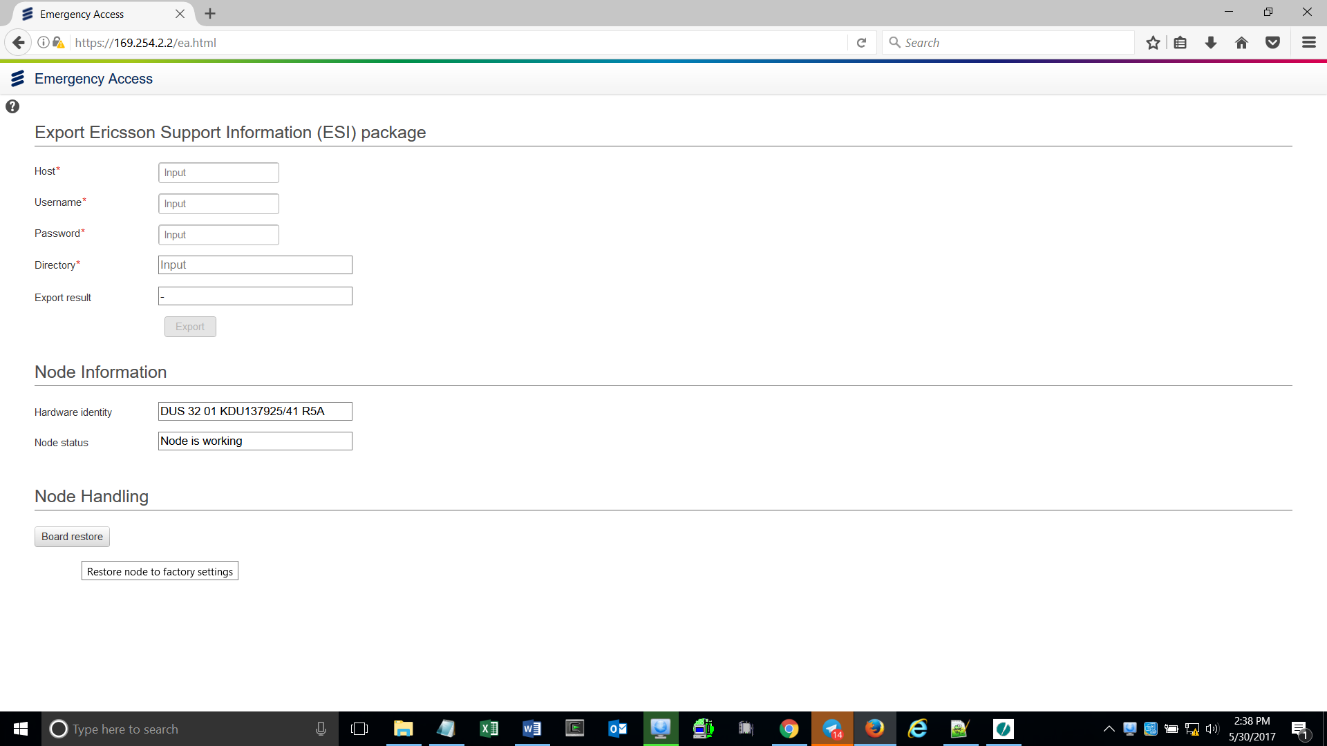

If you need to format Baseband, Click Board restore

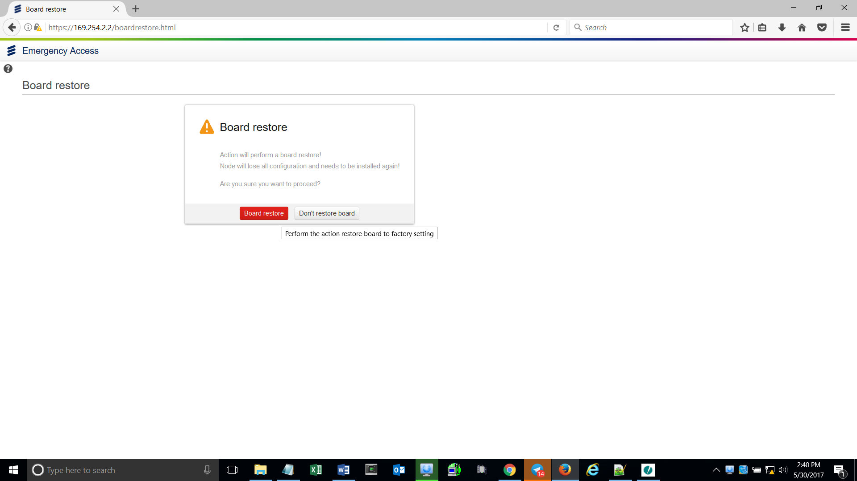

After a couple of minutes, reconnect using https://169.254.2.2

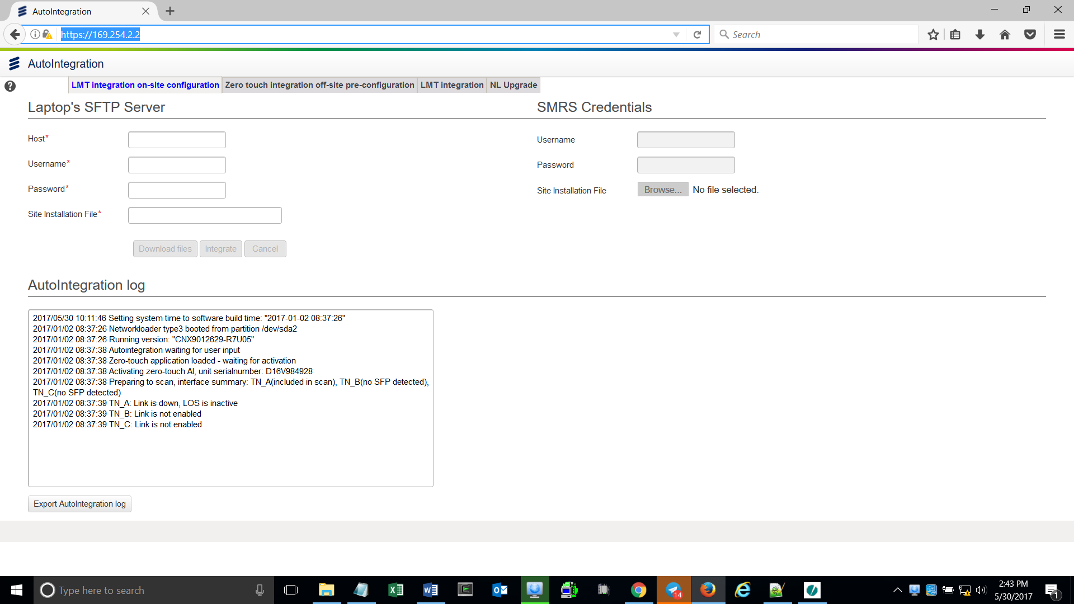

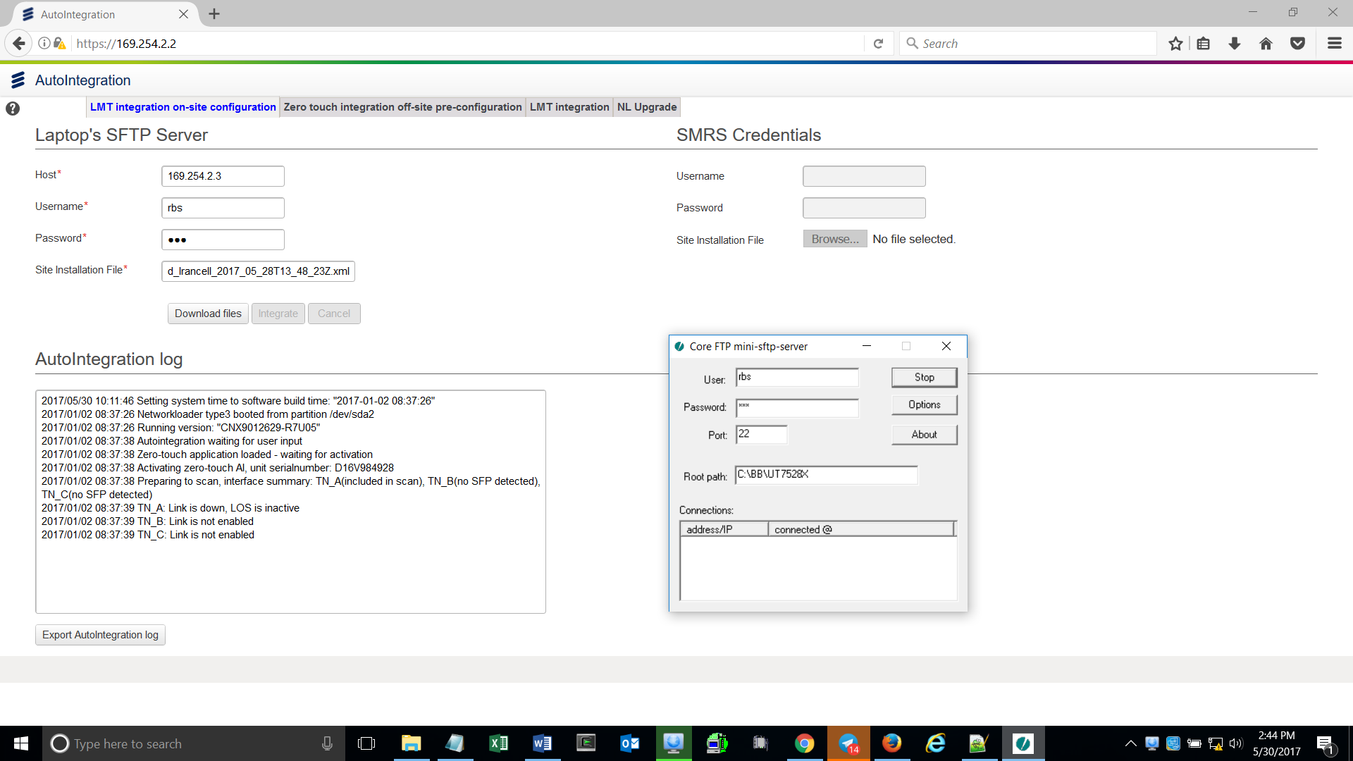

Host: 169.254.2.3

Username: this is the same as the one you have set on the SFTP server

Password: this is the same as the one you have set on the SFTP server

Site Installation File: type in here exactly the filename of your RBS Summary (e.g. RBSSummary_UT7528X_MTN_Irancell_Baseband_Irancell_2017_05_28T13_48_23Z.xml)

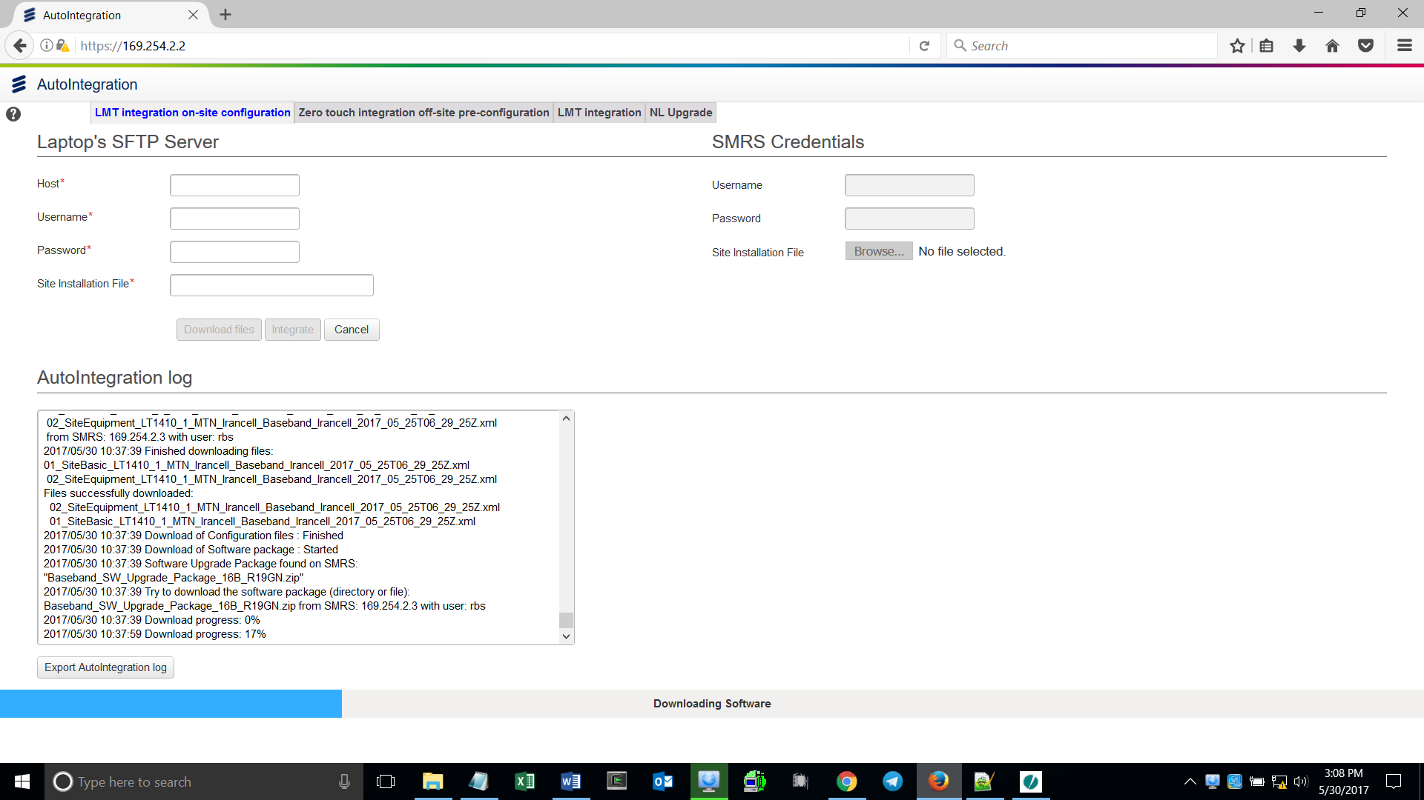

After clicking Download files, you must see a blue line on the bottom indicating download progress & also percentage is shown on the screen.

During this time, it’s normal that Host, Username, Password & Site Installation File are empty.

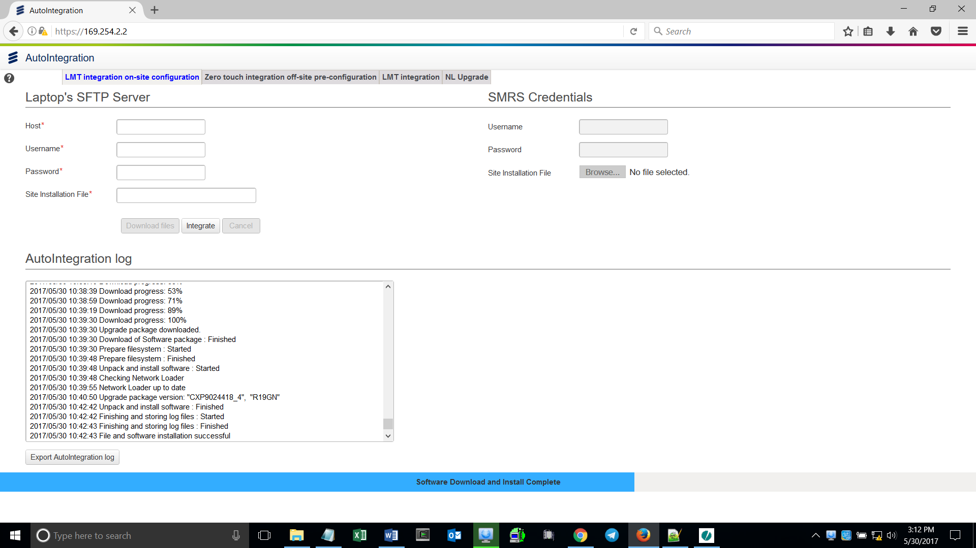

When “Software Download & Install Complete” appears on the blue line, Click Integrate



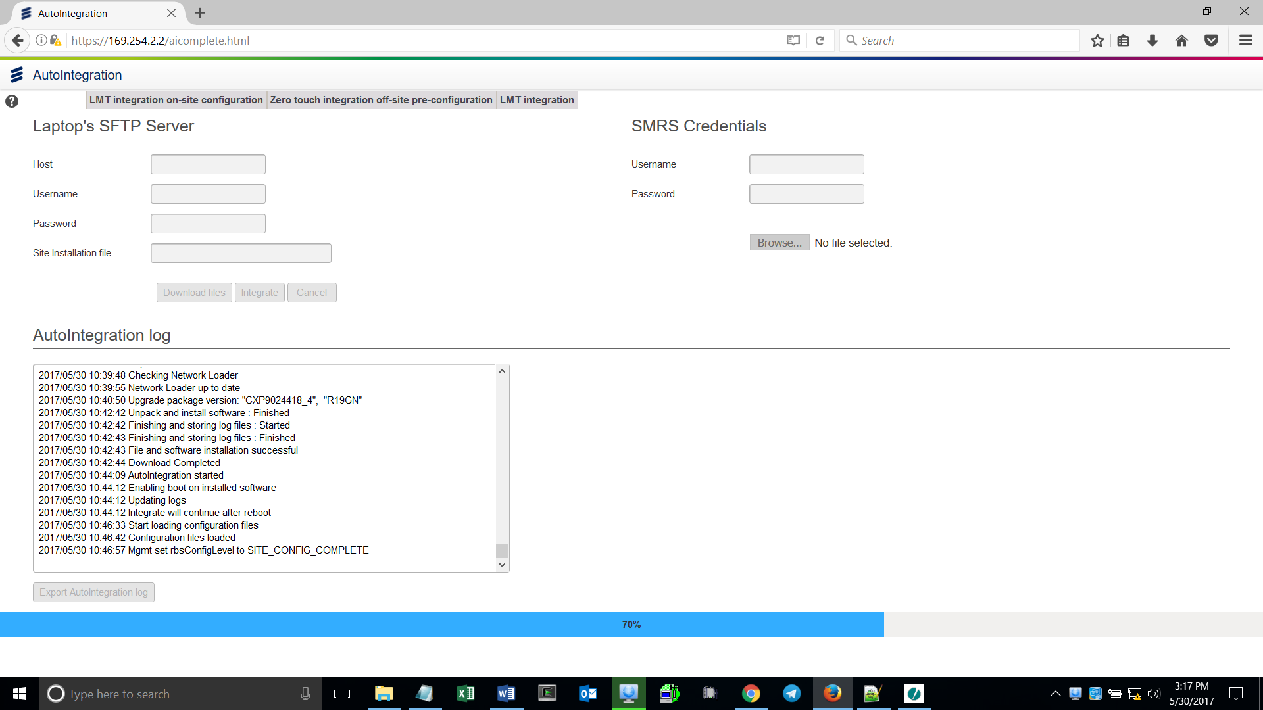

When Integration progress reaches 70%, open Moshell

Username: rbs

Password: rbs

Run all necessary .mos scripts