in case remotely cold/warm restart for RUS/RRUS/DUG/TDM… not solve the issue then we have to power restart the item , and in order to do that we have to set-up the PDU EFuse for remotely control.

You can do that through below steps,

For PDU 01 01 & 01 04 , you just have to set the R (Remote Control) pin in PCR to ON state for all Efuses you want to be remotely controllable as you can see below ,

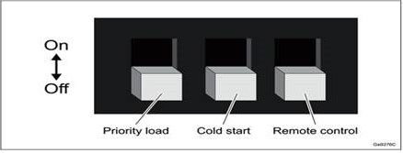

For PDU 02 01 ,you need to remove the upper cover and set the R pin to ON also as you can see below ,

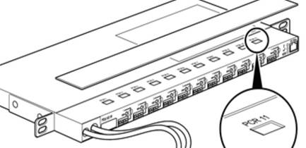

Also we have to set label for each active Efuse so that we can recognize it when we need to restart the item that feed from that EFuse port ,as you can see below ,

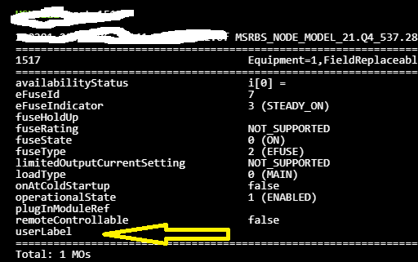

Try to use basic labels like TDM , TN , TCU ,R6K & DUG (main or Co) but please be specific for sectors ,you can use below formula ,

For example if we have RUS 02 B8 then you can use RUS02B8S1 , RUS02B8S2 , RUS02B8S3 (based on their Y-Link connection sequence to DUG/BB/DUW).

Also if we have Radio 2219 B1 , we can use 2219B1S1 ,229B1S2,2219B1S3.

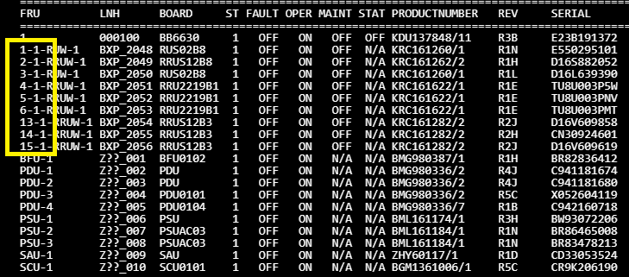

Also please try to make tracker sheet including site code & engineer name in case we face wrong labels.

Above can work only when we have DUW/BB working as master.

Command for DUW as below ,

set Equipment=1,HwUnit=PDU-"pdu number",EFuse="port no. of efuse" userLabel "anylable"

Command for BB as below ,

set Equipment=1,FieldReplaceableUnit=PDU-"pdu number",EFuse="port no. of efuse" userLabel "anylable"